CDC, DEA or HHS Number ________

Full Name (First, Middle and Last): _________________________________________
Date: ______

I, having assumed decision making power independently or having been appointed, to such by a government agency or corporation controlled by government, do require the following individual(s):__________________________________________ herein referenced as “receiver” or “detainee”, to receive the following vaccination(s):
_____________________________________________________________
_____________________________________________________________
I am aware that forced vaccinations are contrary to laws that provide religious and philosophical exemptions, U.S. Constitutional Amendments 4, 5 and 9, and the Nuremberg Code.

I warrant that I took an Oath to abide by and protect the laws of the U.S. Constitution. I am aware that the COVID-19 vaccines have not been properly tested and anyone who takes them is a subject of experimentation. I realize that the Nuremberg code includes principles of informed consent and absence of coercion; properly formulated scientific experimentation; and beneficence towards experiment participants. Nuremberg Code (from United States National Institutes of Health).

1. The VOLUNTARY CONSENT of human subject is absolutely ESSENTIAL. This means that the person involved has legal capacity to give consent; be so situated as to be able to exercise free power of choice, without the intervention of any element of force, fraud, deceit, duress, overreaching, or other ulterior form of constraint or coercion; and have sufficient knowledge and comprehension of the elements of the subject matter involved as to enable her/him to make an understanding and enlightened decision. This latter element requires that before the acceptance of an affirmative decision by the experimental subject there be made known to him the nature, duration, and purpose of the experiment; the method and means by which it is to be conducted; all inconveniences and hazards reasonable to be expected; and the effects upon his health or person which may possibly come from his participation in the experiment. The duty and responsibility for ascertaining the quality of the consent rests upon each individual who initiates, directs or engages in the experiment. It is a PERSONAL duty and responsibility which may NOT be delegated to another with impunity.

2. The experiment should be such as to yield fruitful results for the good of society, not procurable by other methods or means of study, and not random and unnecessary in nature.
3. The experiment should be so designed and based on the results of animal experimentation and knowledge of the natural history of the disease or other problem under study that the anticipated results will justify the performance of the experiment.

4. THE EXPERIMENT SHOULD BE SO CONDUCTED AS TO AVOID ALL PHYSICAL AND MENTAL SUFFERING AND INJURY.

5. NO EXPERIMENT SHOULD BE CONDUCTED WHERE THERE IS A PRIOR REASON TO BELIEVE THAT DEATH OR DISABLING INJURY WILL OCCUR; EXCEPT, PERHAPS, IN THOSE EXPERIMENTS WHERE THE EXPERIMENTAL PHYSICIANS SERVE AS SUBJECTS.

6. The degree of risk to be taken should never exceed that determined by the humanitarian importance of the problem to be solved by the experiment.

7. Proper preparations should be made and adequate facilities provided TO PROTECT THE EXPERIMENTAL SUBJECT AGAINST EVEN REMOTE POSSIBILITIES OF INJURY, DISABILITY OR DEATH.

8. The experiment should be CONDUCTED ONLY BY SCIENTIFICALLY QUALIFIED
PERSONS. The highest degree of skill and care should be required through ALL STAGES of the experiment of those who conduct or engage in the experiment.

9. During the course of the experiment the human subject will be at liberty to bring the experiment to an end if he has reached the physical or mental state where continuation of the experiment seems to him to be impossible.

10. During the course of the experiment the scientist in charge must be prepared to terminate the experiment at any stage, if he has probable cause to believe, in the exercise of good faith, superior skill and careful judgment required of her/him that a continuation of the experiment IS LIKELY TO RESULT IN INJURY, DISABILITY OR DEATH TO THE EXPERIMENTAL SUBJECT.

Source: Trials of War Criminals before the Nuremberg Military Tribunals under Control Council Law No. 10, Vol. 2, pp. 181-182. Washington, D.C.: U.S. Government Printing Office

I agree that the stated individual(s) are in good to perfect health prior to the administration of such immunization(s). If any damage occurs to the receiver(s) stated above, I personally accept full responsibility for any and all damages resulting from such immunizations. As a result, I agree to provide compensation amounting to at least 1,000,000 lawful dollars, constitutional money pursuant to Article I, Section 10 of The Constitution of the United States, to the family(s) of the man(men) I am requiring to receive the aforementioned vaccinations for each resulting vaccine related injury(s) and/or disease(s) as follows:
Shaken baby syndrome: http://www.vaclib.org/basic/sbsindex.htm
Cerebral bleeding: http://www.vaclib.org/basic/sbsrebut.htm
Cancer: http://www.sv40cancer.com/
Tumors: http://www.gulfwarvets.com/virus.htm
Asthma: http://vaccines.net/Asthma/allergie.htm
Auto-immune disease(s): http://healthresearchtoday.com/lupus/whatislupus.htm
Brain damage: http://www.vaclib.org/news/2006/pentacel.htm
Mental retardation: http://www.vaclib.org/news/2006/pentacel.htm
Crippling arthritis: http://www.vaclib.org/intro/hepbinfo.htm
Mercury poisoning: http://www.gulfwarvets.com/kids.htm
Diabetes: http://vaccines.net/diabetes.htm
Blindness: http://www.vaclib.org/email/lymefda.htm
Loss of IQ: http://www.vaclib.org/email/autismviera.htm
Seizures: http://www.vaclib.org/email/seizures.htm
Chronic fatigue syndrome: http://healthresearchtoday.com/fibromyalgia/book_104.htm
Cardiac problems, such as angina or cardiac arrest

Acceptance of Responsibility for COVID-19 Vaccine Consequences
I understand that all of those conditions/diseases that are induced by vaccination are incurable by modern medicine, but easily prevented by abstinence from vaccinations.
I have a thorough understanding of the risks and benefits of all the medications that I enforce. In the case of (detainee’s name) _____________________________, age _________ , whom I have examined, I find that certain risk factors exist that justify the recommended vaccinations. The following is a list of said risk factors and the vaccinations that will protect against them:
Risk Factor ______________________________________________________
Vaccination ______________________________________________________
Risk Factor ______________________________________________________
Vaccination ______________________________________________________
Risk Factor ______________________________________________________
Vaccination ______________________________________________________
Risk Factor_______________________________________________________
Vaccination ______________________________________________________
I am aware that in addition to the viral and bacterial RNA or DNA that is part of the vaccines, below are some of the fillers considered inert but which have harmful side effects:
aluminum hydroxide (directly linked to Alzheimer's Disease)
aluminum phosphate (directly linked to Alzheimer's Disease)
ammonium sulfate (an inorganic chemical compound used a fertilizer and "protein purifier"; known to cause kidney & liver damage, gastrointestinal dysfunctions)
amphotericin B (an "antifungal disinfectant” that damages the urinary tract, bowels, heart functions)
animal tissues: pig blood, horse blood, rabbit brain, dog kidney, monkey kidney, chick embryo, chicken egg, duck egg, and calf (bovine) serum, fetal bovine serum VERO cells, a continuous line of monkey kidney cells, and washed sheep’s red blood cells.
(Those build foundation for neurological diseases)
betapropiolactone (disinfectant)
Ethylene glycol (antifreeze, proven to have extreme neurotoxic side effects)
formaldehyde (used as a preservative, embalming fluid, and disinfectant, known to cause cancer, chronic bronchitis, eye irritation and numerous other diseases)
formalin (used as a disinfectant or anti-bacterial, containing 37% formaldehyde)
gelatin (causes allergic reactions and anaphylaxis usually associated with sensitivity to processed egg or gelatin)
Gentamycin (antibiotic: destroys digestion and impairs healing)
Glycerol (A syrupy, sweet, colorless or yellowish liquid, C3H8O3, obtained from fats and oils as a byproduct of saponification and used as a solvent, an antifreeze, a plasticizer, and a sweetener and in the manufacture of dynamite, cosmetics, liquid soaps, inks, and lubricants)
MF-59 (oil-based and composed of squalene, Tween 80 and Span85. All oil adjuvants injected into rats were found to be toxic, caused disease similar to multiple sclerosis which left them crippled and dragging their paralyzed hindquarters)
human diploid cells (from aborted fetal tissue)
hydrolyzed gelatin (obtained by chemical extraction from the skin, white connective tissue and bones of animals, such as cowhide splits, bones (ossein), pork skin, and fish skin)
monosodium glutamate (MSG; causes cancer in humans, also linked to obesity)
neomycin (antibiotic: destroys digestion and impairs healing)
neomycin sulfate (antibiotic: destroys digestion and impairs healing)
nonoxynol (toxic chemotherapy used to treat venereal diseases)
octoxinol 9 (toxic chemical used in vagina to kill sperm)
phenol red indicator (a highly toxic carolic acid disinfectant dye, attributed to liver, kidney, heart and respiratory damage)
phenoxyethanol (antifreeze, proven to have extreme neurotoxic side effects)
potassium diphosphate (destroys libido and motivation)
potassium monophosphate (destroys libido and motivation)
polymyxin B (antibiotic: destroys digestion, damages liver and kidneys, and impairs healing)
polysorbate 20 (trademarked Tween 20; emulsifier that often prevents absorption of nutrients causing malnutrition)
polysorbate 80 (trademarked Tween 80: a preservative that can cause severe allergic reactions including anaphylaxis)
porcine (pig)
pancreatic hydrolysate of casein (isolated concentration of certain proteins that cause nutritional imbalances, allergies and often excessive hunger or the opposite anorexia)
residual MRC5 proteins (chemically isolated toxic proteins from cancerous DNA)
resin (causes allergic reactions)
sodium phosphate (solvent, dangerous, even life-threatening, toxicity may occur while using sodium phosphate if you have kidney disease, have congestive heart failure, have an electrolyte imbalance; or are on a sodium restricted diet)
sorbitol (sugar alcohol that dissolve intestinal villi)
Squalene (causes severe arthritis and lupus in humans at only 10-20 parts per billion)
sucrose (dissolves cellular walls and intestinal villi)
thimerosal (mercury; a neurotoxin linked to psychological, neurological & immunological problems. Nervous system damage, kidney disease, birth defects, dental problems, mood swings, mental changes, hallucinations, memory loss, nerve damage and inability to concentrate can occur. Symptoms also include tremors, loss of dermal sensitivity, slurred speech and, in rare cases, even death and paralysis. This additive alone was the catalyst for another recent Class Action Lawsuit organized by mothers of children born with Autism & the many related behavioral disorders associated with it. Autism is now occurring at levels never seen before in history, 1 in 67. The average used to be 1 in 20,000.)
tri(n)butylphosphate (solvent and plasticizer)
Triton X100 (a strong detergent)
Additionally, I have considered the synergistic toxic effects produced by combining those toxins. I realize that side effects compound and more severe reactions result from combining toxins.

NO PROPER TEST has been executed and released to the public. I understand that anyone who takes COVID-19 vaccines is the experiment.
I am aware that the expected harmful and possibly fatal side effects admitted by
pharmaceutical manufacturers and listed on vaccine package inserts are:
Local injection site reactions (including pain, pain limiting limb movement, redness, swelling, warmth, ecchymosis, induration). I understand that past symptoms from Government enforced vaccines have included: abdominal pain, arthralgia, asthenia, blood disorders, cardiovascular, disorders, chest pain, chills, cough, diarrhea, digestive disorders, dizziness, dyspnea, facial edema, fatigue, febrile convulsions, fever, Guillain-Barré Syndrome (often resulting in death), headache, hot flashes/flushes, hypersensitivity reactions (including throat and/or mouth edema), hypersensitivity reactions have lead to anaphylactic shock and death, immune system disorders, loss of appetite, lymphadenopathy (local), lymphatic disorders, malaise, metabolic disorders, myalgia, myasthenia, myelitis (including encephalomyelitis and transverse myelitis), maculopapular rash, nausea, nervous system disorders, neuralgia, neuropathy (including neuritis), nutritional disorders, paraesthesia, paralysis (including Bell’s Palsy), pharyngitis, pruritus, rashes (non-specific), respiratory disorders, rhinitis, shivering, Stevens-Johnson syndrome, syncope shortly after vaccination, thrombocytopenia (transient), urticaria, vasculitis (in rare cases with transient renal involvement), vesiculobulbous rash, vomit.

I am also aware that tests have proved that flu shots don’t work, such as the following:

- According to the 2006 Cochrane Database of Systematic Reviews, 51 separate studies concluded the flu vaccine worked no better than a placebo in 260,000 children ranging in age from six months to 23 months.
- A study published in the October 2008 Archives of Pediatric and Adolescent Medicine found flu vaccines in young children have made no difference in the number of flu-related doctor and hospital visits.
- As reported in a 2004 publication of the Archives of Disease in Childhood, a study of 800 children with asthma concluded those receiving a flu vaccine had a significantly increased risk of asthma-related doctor and emergency room visits.
- A study released at the 2009 American Thoracic Society International Conference showed children with asthma who received FluMist had a 3-fold increased risk for hospitalization.
Not only are flu vaccines ineffective in preventing flu in children, they are equally ineffective for adults, including elderly.

- According to the 2007 Cochrane Database of Systematic Reviews, studies of over 65,000 healthy adults concluded vaccinations reduced the risk of flu by only six percent, and reduced missed work days by less than a single day. Vaccinations did not reduce the number of people who sought medical help or took time off from work.
- The 2006 Cochrane Database also includes a review of 64 vaccination studies of the elderly across nearly 100 flu seasons. The studies showed flu vaccines were ineffective in preventing the flu in either nursing home patients or elderly living in the community.

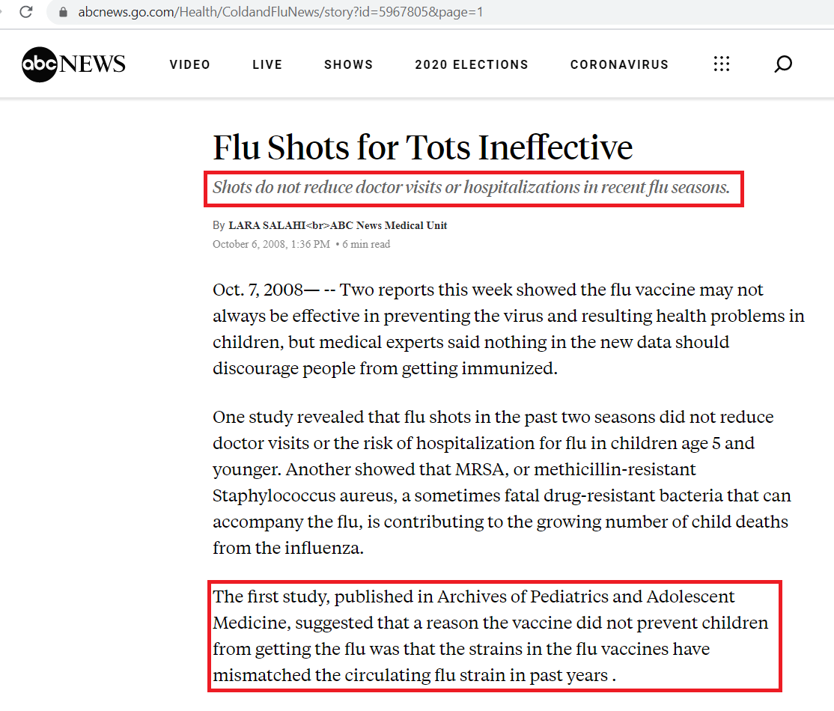
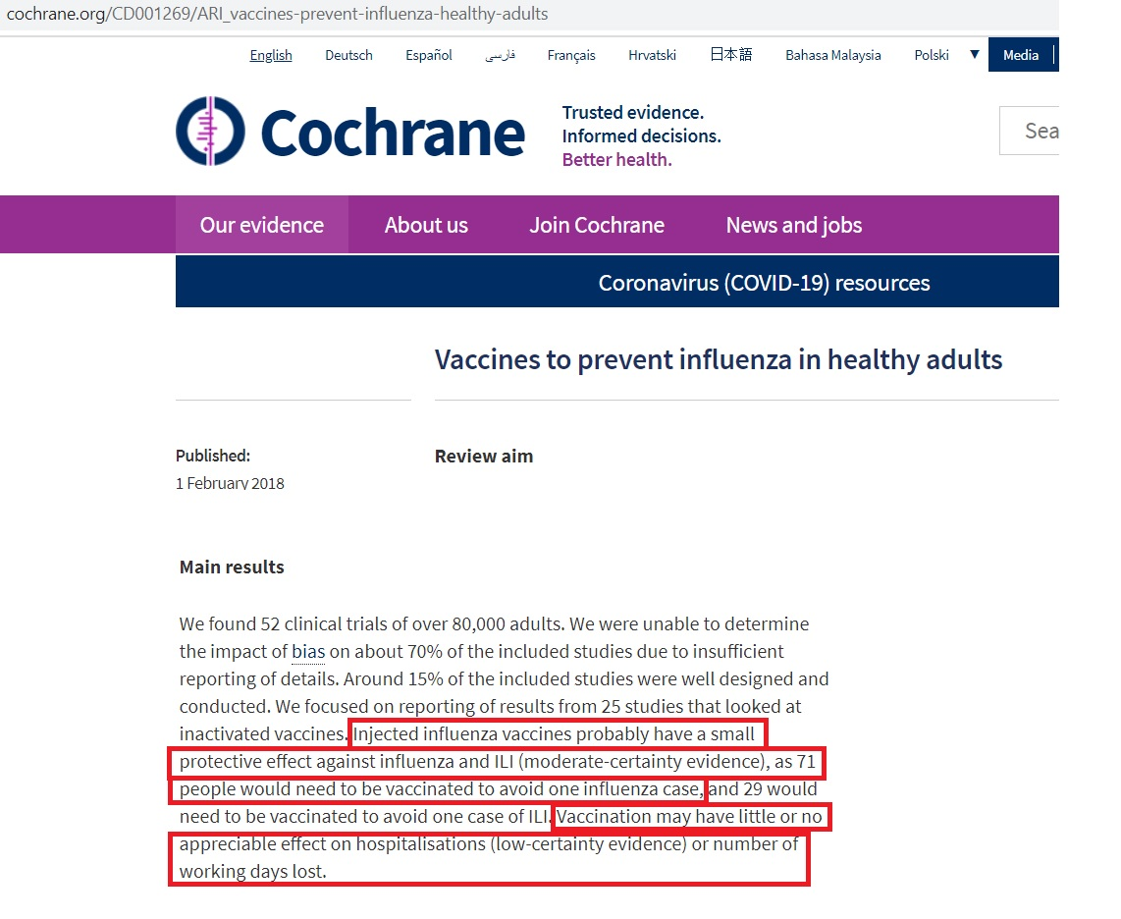

- A study published in the Lancet last year found that influenza vaccination was NOT associated with a reduced risk of pneumonia in older people. This supports a study done five years ago, published in The New England Journal of Medicine.

Acceptance of Responsibility for COVID-19 Vaccine Consequences
Research published in the American Journal of Respiratory and Critical Care Medicine also confirms that there has been no decrease in deaths from influenza and pneumonia, despite the fact that vaccination coverage among the elderly has increased from 15 percent in 1980 to 65 percent. Mortality benefits of influenza vaccination in elderly people: an ongoing controversy by Simonsen L, Taylor RJ, Viboud C, Miller MA, Jackson LA,

“We conclude that frailty selection bias and use of non-specific endpoints such as all-cause mortality have led cohort studies to greatly exaggerate vaccine benefits.”

I hereby warrant that the vaccines I am enforcing do not contain any tissue from aborted human infants (also known as "fetuses").

In addition to the recommended vaccinations as protections against the above cited risk factors, I have recommended other non-vaccine measures to protect the health of detainee and have enumerated said non-vaccine measures on Exhibit A, attached hereto, "Non-vaccine Measures to Protect Against Risk Factors."
I issue this Government Agent’s Warranty of Vaccine Safety in my professional capacity as government agent to detainee(s). Under Nuremburg Code, regardless of the legal entity under which I act to enforce vaccinations, I issue this statement in both my business and individual capacities and hereby waive any statutory, Common Law, Constitutional, UCC, international treaty, and any other legal immunities from liability lawsuits in the instant case, according to the Nuremburg rules on injected medications.
I further warrant that I was notified that detainee’s medical care physician has deemed all vaccines are dangerous to detainee’s health and well-being because of past medical conditions.
I issue this document of my own free will after consultation with competent legal counsel whose name is _______________________, an attorney admitted to the Bar in the State of _________________________.

Name of Government agent: print):_____________________________

Position:__________________

Signature:_________________________________________Date:________
Witness: _____________________________________________Date:________
Notary Public: _________________________________________Date:________

AAJONUS’ INSTRUCTIONS FOR THE ACCEPTANCE OF RESPONSIBILITY DOCUMENT
“It is quite obvious that no individual in his right mind will sign this document. Please do not expect anyone to sign it and do not be confrontational. Better that your attitude be humble, informative and calm; at times maybe even gently pleading. By getting the vaccination enforcement officer to read the document s/he has been duly advised of your rights and her/his non-immunity liabilities and responsibilities. If s/he tries to force you to take vaccinations, this document should lose confidence in her/his authority to force vaccinations on you. Furthermore, it helps defuse authoritative intimidation when it
occurs. If the official refuses to sign document, ask the following questions:
"Why would you want me to accept vaccination when the vaccine has not been tested or proved safe and it has a lot of published side effects that include paralysis and death?”
”Why would you want me to accept vaccination when the vaccine has over 35 toxic ingredients that cause harm and even death?”
“Why would you be willing to break your oath to protect my rights under U.S. Constitution and Nuremberg Codes?”
”Since there were no laboratory-confirmed cases of swine flu (H1N1 virus) [He wrote this during the recent swineflu hoax in 2009-DS] causing death, there is no epidemic. Why do you think that you can force me to have vaccinations when there is no epidemic threat that warrants such deprivation of my rights without impunity?”
"Do you realize that because there is no evidence of epidemic, you will be liable for any harm to me by vaccination?”
“How much do you think your health and life are worth if the vaccinations caused you severe damage or death?”
"How do you feel about risking my life? Does it bother you that your force could cause my death or disease?”
"What does the law state that you will follow to force me to be vaccinated?"
"Who benefits financially from this program?"
He or she should get the message and probably will not force you to be vaccinated.
If you have a letter from your medical physician that states you are at high risk of side effects including death from taking vaccinations, and that you cannot receive vaccinations, present the letter to the officer. It will be a way for the officer to release you unvaccinated without worrying about his job and the consequences if he is held liable for any harm to you.”

https://www.ncbi.nlm.nih.gov/pubmed/17897608

